Report for: | Cabinet
Date of Meeting: | 16 November 2023
Subject: | Annual Youth Justice Plan
Key Decision: | Yes, the decision is significant in terms of its effects on communities living across all the wards of the borough.
Responsible Officer: | Parmjit Chahal – Director of Children’s Services
Portfolio Holder: | Cllr Hitesh Karia - Portfolio Holder for Children’s Services
Exempt: | No
Decision subject to Call-in: | No, as the decision is reserved to Council.
Wards affected: | All wards
Enclosures: | Appendix 1 - “The Harrow Youth Justice Plan 2023-24 Update”  Appendix 2 - Equalities Impact Assessment  Appendix 3 – Reference from Overview and Scrutiny Committee, 7 November 2023  (To Follow)

Section 1 – Summary and Recommendations
This report sets out how the Harrow Youth Justice Partnership establishes a team and system compliant with Section 39 of the Crime & Disorder Act 1998 to coordinate effective provision of Youth Justice Services in Harrow and provides the annual Youth Justice Plan for approval by Council.

Recommendations:
Cabinet is requested to recommend to Council that the Harrow Youth Justice Plan be approved.

Reason:
The establishment of a Youth Justice Service is a statutory requirement (under the Crime and Disorder Act 1998). There are certain partners who must form part of the Multi-Disciplinary Team including Police, Probation, Education, Health and Social Work and others may form part of the team and partnership governing Board (in Harrow this is the Youth Justice Partnership [Management Board] which also reports to the Safer Harrow (Community Safety Partnership)). Under the Crime and Disorder Act 1998 the authority is also required to produce (and implement) a Plan (Youth Justice Plan), and this Plan must be approved by Council.

Section 2 – Report

Introductory paragraph
The Annual Harrow Youth Justice Plan outlines how the Harrow Youth Justice Partnership Board establishes a service, a strategy and a system which aims to keep residents safe and supports children from becoming involved (or further involved) within the Criminal Justice System. Children who commit crimes or antisocial behaviour or are at risk or vulnerable to being exploited into committing crime through the organised activity of others come to notice either through early identification (for example by arrest and release with or without bail, charge or conditions) or as a result of admitting or being found guilty through a Court of a criminal offence. Children who are subject to Court Orders will be ordered to comply with a Youth Justice Service who will carry out a child first focused person centred assessment of needs. Such assessment will be psychologically informed, trying to get to an understanding of the underlying reasons for offending behaviours. An intervention plan will then be devised to address these reasons. This may include trying to reduce vulnerabilities such as poor educational attainment, misuse of substances, poor mental and emotional health, poor physical health and the negative impact of poverty. As such the Youth Justice System is focused on much more than only stopping offending behaviour, although that is of course a key indicator of success. The system is also focused on generational improvement in life chances of young people who are at risk. In addition, a restorative approach is taken towards both victims and perpetrators of crimes. Our system encourages, where safe to do so and victims agree, for perpetrators to attempt to make direct or indirect amends towards victims. We also support victims independently to recover from the adverse impact of crimes against them. However, we often find that perpetrators have been victims and the line is not always clear.

By the council understanding the system and approving the priorities and resources required to support these as outlined in the annual Youth Justice Plan the council are assuring residents of its intention and commitment to keep them safe from crime while at the same time supporting its vulnerable younger residents and their families from becoming involved in the negative impact of crime and the negative impacts of the criminal justice system.

Options considered
Establishing a Youth Justice System and the core composition of the professionals which must take part in such a system is a statutory requirement. (Section 39 Crime and Disorder Act 1998). It is also a requirement to produce and Annual Youth Justice Plan.

The priorities established are a matter of local discretion based on data reflecting types of reported crimes committed as well as local intelligence regarding what crimes may be being committed and which young people are at risk of committing them even though they are not at this point subject to a formal finding or admission of guilt.

The level of prevention and early intervention work is a judgement based on available resources and the ability to understand if prevention work is actually working. As by its nature one cannot report on prevention apart from through extrapolation of what was expected to happen but did not. Our data shows that our levels of reoffending (specifically the amount people committing reoffences) is decreasing overall. However, the overall smaller cohort are a more complex and entrenched group and the number of re-offences they commit reflects this.

Currently the service is mainly established on the basis of addressing the reported and admitted levels of crime. However, the service has awarded a small grant of around £50K per year starting in Autumn 2023 (until end of March 2025) specifically to address children who have only been arrested once and not been otherwise involved in the criminal justice system to work with them so they do not get arrested or otherwise involved in the criminal justice system. From next year (April 2024) it may be an option to attempt to shift the resourcing towards this specific cohort of children to further reduce inequalities and support those children further in need to reduce their vulnerability to being involved in the criminal justice system.

However, for now there are no specific alternative options, and the Youth Justice Plan needs to be approved by Council for implementation, and this is the expectation of the Youth Justice Board who provide the grant money.

Background
The attached Harrow Annual Youth Justice Plan 2023-24 outlines the current situation, the resources and staffing arrangements. No change is currently being sought but oversight and approval of the current priorities and arrangements for meeting the statutory duties outlined in Section 39 Crime and Disorder Act 1998 are being recommended.

Ward Councillors’ comments n/a

Performance Issues
Relevant key performance data is reported to the Partnership Management Board and the national Youth Justice Board (YJB) on a quarterly basis. The current organisational arrangement shows that a good level of service provision is in place. If the priorities or available resourcing was to be substantially amended it is possible that our performance would be negatively impacted. This could impact on the YJB’s decision to award their annual grant funding of around £250K.

Environmental Implications
The arrangements for establishing a service and partnership arrangement for governance and strategy have a minimal impact on the environment. The Governance Board meets quarterly mostly using Teams technology though there are occasional in person meetings which have a moderate impact if attendees choose to drive to these. The service itself involves meeting with Young People in various settings including at their residences, in secure locations such as Police Stations and Prisons and in community settings such as Youth centres and other community venues including schools. The environmental impact of such meetings is minimal though for some visits to young people placed in secure settings many miles away travel arrangements need to be made.

Data Protection Implications
Data generated as a result of establishing these Youth Justice Systems is done so as part of a public task and legal obligation and this provides the legal basis for the data processing of relevant data. Work with those at risk of offending is carried out by consent. The legal basis of such data processing is outlined in the Children’s Services privacy notices on the Harrow Website.

Risk Management Implications
The risk of Council not approving this year’s annual plan is that the document will not be seen as in a state of readiness by the Youth Justice Board. The impact of this would be substantial as may have a high likelihood and critical impact of reviewing their grant funding of around £250K per year. It may also raise a question to the relevant statutory inspection body to consider bringing forward an inspection which would be a medium likelihood and moderate impact risk.

Risks included on corporate or directorate risk register? Yes

Separate risk register in place? No

The relevant risks are summarised below.

The following key risks should be taken into account when agreeing the recommendations in this report:

Risk Description | Mitigations | RAG Status
If the report’s recommendations for the Plan to approved by Council are not agreed, a statutory and compulsory inspection of Youth Justice Services in Harrow may be precipitated and brought forward again representing a further risk to the Council | - Agreement to the report’s recommendations if given will mitigate this risk downwards from amber to green | AMBER
Responsibilities for reporting of the delivery of the 2023/24 Plan are should be clarified | - Performance against 9 Key indicators are set to be reported to the National Youth Justice Board from Sept 2023. Once started to be reported this will mitigate the risk downwards towards Green | AMBER
The consultation with users of the service in the strategic agreement of priorities and design of the plan is insufficient | - There is a part of the service plan and work of the local Board to include the views of children directly impacted by the YJ Service in it’s future strategy and direction. This would mitigate the risk downwards towards Green. | AMBER

Procurement Implications
“There are no procurement implications arising from the recommendation set out in this report”.

Legal Implications
Maintaining a set of partnership arrangements to provide suitable Youth Justice Services for Harrow is a statutory requirement under section 39 Crime and Disorder Act 1998. Under section 40 of the Act, the authority must, after consultation with the relevant partner agencies, formulate and implement an annual Youth Justice Plan setting out how youth justice services in the area are to be provided and funded, and how the youth offending team(s) established by them are to be composed and funded, how they will operate and what functions they will carry out.

Local authorities have a statutory duty to submit the annual youth justice plan to the Youth Justice Board.

The Youth Justice Plan must be signed off by full Council in accordance with the Local Authorities (Functions and Responsibilities) (England) Regulations 2000, and the Council’s Constitution. If this has not taken place before 30 June (2023), the statutory guidance still allows the plan to be submitted to the Youth Justice Board (subject to conditions) in order that the Youth Justice Grant payment can be made in time.

Financial Implications
- The table below shows the income and expenditure of the Harrow YJS for 2022-23
INCOME | Youth Justice Board | Local Authority | Police | Probation | Health | Total
Cash | £257,636 | £801,387 |  | £5,000 |  | £1,064,023
In-kind |  |  | £100,134 | £31,709 | £33,272 | £165,115
Total income | £257,636 | £801,387 | £100,134 | £36,709 | £33,272 | £1,229,138

EXPENDITURE | Youth Justice Board | Local Authority | Police | Probation | Health | Total
Salaries | £219,394 | £686,692 | £100,134 | £31,709 | £33,272 | £1,071,201
Activity costs | £6,031 | £13,877 |  | £5,000 |  | £24,908
Accommodation | £0 | £0 |  |  |  | £0
Overheads | £32,211 | £100,818 |  |  |  | £133,029
Equipment | £0 | £0 |  |  |  | £0
Total expenditure | £257,636 | £801,387 | £100,134 | £36,709 | £33,272 | £1,229,138

- Funding from the Youth Justice Board is provided through an annual grant managed by the Council. Funding from the Police, Probation Service and Health are provided in-kind.

- The make up of the Harrow YJS is shown in the structure chart below
- 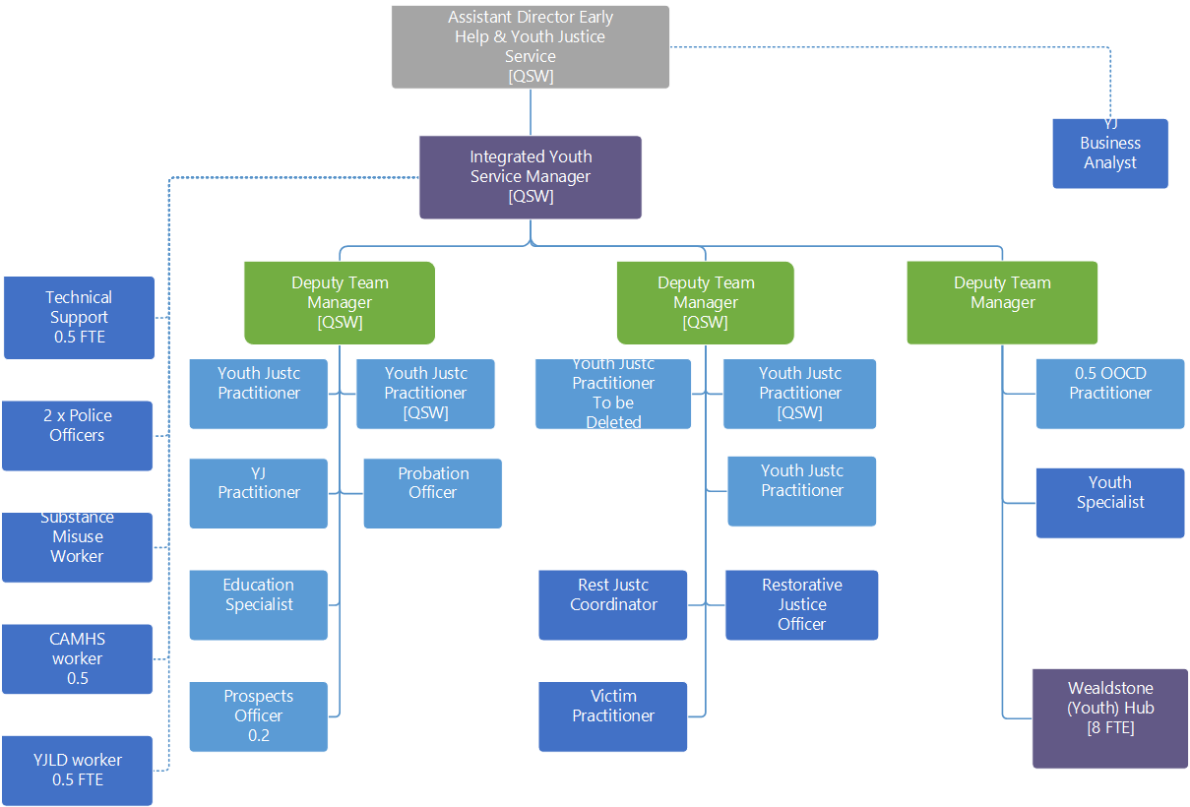

- In addition to the budgets listed above, specific grants may be bid for from time to time but these will not impact on the funding for the existing established service as they will have additional specific outcome goals.
- All activities within the Youth Justice Plan will be managed within existing budgets

Equalities implications / Public Sector Equality Duty
The Annual Youth Justice Plan does specifically address recognising the disproportionate over representation of Black Caribbean Young men within the Criminal Justice System as a whole and within London and indeed within Harrow. One of the priorities in the plan is to attempt to find ways to seek to address this disproportionality through a three pronged approach of a) supporting the directly impacted young people, b) ensuring all YJS staff are suitably professionally supported to recognise the impact of unconscious bias and c) challenging any direct or indirect forms of discrimination amongst our partner organisations and across Harrow if we ever encounter it.

The EQIA therefore concluded that there is no negative impact to mitigate against. The EQIA is attached as an appendix

Council Priorities

Please identify how the decision sought delivers this priority.

- A council that puts residents first

- A borough that is clean and safe

- A place where those in need are supported

The Annual Harrow Youth Justice Plan outlines how the Harrow Youth Justice Partnership Board establishes a service, a strategy and a system which aims to keep residents safe and supports children from becoming involved (or further involved) within the Criminal Justice System. Children who commit crimes or antisocial behaviour or are at risk or vulnerable to being exploited into committing crime through the organised activity of others come to notice either through early identification (for example by arrest and release with or without bail, charge or conditions) or as a result of admitting or being found guilty through a Court of a criminal offence.

Children who are subject to Court Orders will be ordered to comply with a Youth Justice Service who will carry out a child first focused person-centred assessment of needs. Such assessment will be psychologically informed, trying to get to an understanding of the underlying reasons for offending behaviours. An intervention plan will then be devised to address these reasons. This may include trying to reduce vulnerabilities such as poor educational attainment, misuse of substances, poor mental and emotional health, poor physical health and the negative impact of poverty. As such the Youth Justice System is focused on much more than only stopping offending behaviour, although that is of course a key indicator of success.

The system is also focused on generational improvement in life chances of young people who are at risk. In addition, a restorative approach is taken towards both victims and perpetrators of crimes. Our system encourages, where safe to do so and victims agree, for perpetrators to attempt to make direct or indirect amends towards victims. We also support victims independently to recover from the adverse impact of crimes against them. However, we often find that perpetrators have been victims and the line is not always clear.

By the council understanding the system and approving the priorities and resources required to support these as outlined in the annual Youth Justice Plan the council are assuring residents of it’s intention and commitment to keep them safe from crime while at the same time supporting it’s vulnerable younger residents and their families from becoming involved in the negative impact of crime and the negative impacts of the criminal justice system.

The priorities in the annual youth justice plan are a matter of local discretion based on data reflecting types of reported crimes committed as well as local intelligence regarding what crimes may be being committed and which young people are at risk of committing them even though they are not at this point subject to a formal finding or admission of guilt.

The level of prevention and early intervention work is a judgement based on available resources and the ability to understand if prevention work is actually working. As by its nature one cannot report on prevention apart from through extrapolation of what was expected to happen but did not. Our data shows that our levels of reoffending (specifically the amount people committing reoffences) is decreasing overall. However, the overall smaller cohort are a more complex and entrenched group and the number of re-offences they commit reflects this.

Currently the service is mainly established on the basis of addressing the reported and admitted levels of crime. However, the service has awarded a small grant of around £50K per year starting in Autumn 2023 (until end of March 2025) specifically to address children who have only been arrested once and not been otherwise involved in the criminal justice system to work with them so they do not get arrested or otherwise involved in the criminal justice system. From next year (April 2024) it may be an option to attempt to shift the resourcing towards this specific cohort of children to further reduce inequalities and support those children further in need to reduce their vulnerability to being involved in the criminal justice system.

Section 3 - Statutory Officer Clearance
Statutory Officer: Jo Frost
Signed on behalf the Chief Financial Officer
Date: 20 September 2023
Statutory Officer: Paresh Mehta
Signed on behalf of the Monitoring Officer
Date: 8 November 2023
Director of Children’s Services: Parmjit Chahal
Signed on behalf of the Corporate Director
Date: 6 November 2023
Head of Procurement: Nimesh Mehta
Signed by the Head of Procurement
Date: 20 September 2023
Head of Internal Audit: Neale Burns
Signed on behalf of the Head of Internal Audit

Date: 21 September 2023

Has the Portfolio Holder(s) been consulted? Yes ☒

Mandatory Checks

Ward Councillors notified: NO, as it impacts on all Wards

EqIA carried out: YES

EqIA cleared by: Jennifer Rock
Date: 27 September 2023, further enhanced with additional specific data on 19/10/2023

Section 4 - Contact Details and Background Papers
Contact:
Mark Scanlon
Assistant Director for Youth Justice and Early Help
07860 828861 / mark.scanlon@harrow.gov.uk

Background Papers:
- Section 39 of the Crime and Disorder Act 1998 (linked as follows: https://www.legislation.gov.uk/ukpga/1998/37/section/39

Call-in waived by the Chair of Overview and Scrutiny Committee
NO

